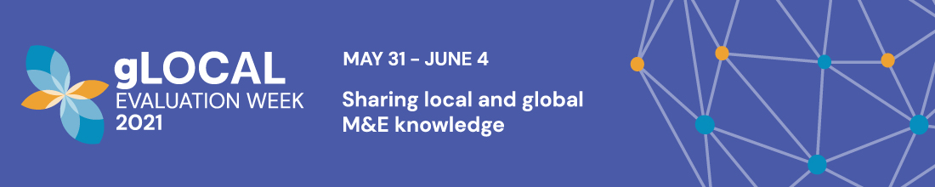

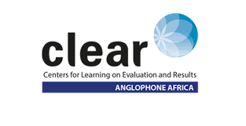

**Evaluation Systems Unit proposal, CLEAR-AA**

**Submitted by:** Dr. Takunda Chirau (Deputy Director, CLEAR-AA); Mr. Ayabulela Dlakavu (M&E Technical Specialist, CLEAR-AA); and Ms. Banele Masilela (Researcher, CLEAR-AA)

**Theme 4 - How can we strengthen National M&E Systems so countries are more resilient and better prepared to build back better?**

1. **Background to CLEAR-AA and Evaluation Systems Programmatic Area/unit**

The Centre for Learning on Evaluation and Results –Anglophone Africa (CLEAR-AA) works in African English-speaking countries to build and/or strengthen monitoring and evaluation system(s). CLEAR-AA is doing and has done work Zambia, Uganda, Lesotho, Botswana, Malawi, Tanzania, Namibia, Kenya, Nigeria and Liberia. At times CLEAR-AA partners with CLEAR Francophone Africa in countries like Madagascar, Burundi, Angola and so forth. These countries constitute the monitoring and evaluation capacity strengthening country programmes that CLEAR-AA is implementing and these programs vary in depth and breadth. This variance in the depth of country programs is mainly influenced by the country’s architecture or configuration of the M&E system as well as political, economic and value system of a country.

CLEAR-AA partners with an in-country government institution with the mandate of executing oversight and coordination of public sector monitoring and evaluation functions. Such a public sector M&E oversight institution is normally located within the executive arm of the State. CLEAR-AA takes a consultative, participatory, and systems approach to the development of the country’s M&E systems so that it is one in which M&E stakeholders’ (government and non-state actors) voices are valued. The long-term goal is to create an integrated, comprehensive country-owned, and led M&E system that adds real value to the nation’s development outcomes and governance processes. To achieve that, a country program is established, co-managed by CLEAR-AA and the in-country M&E oversight institution.

CLEAR-AA is comprised of five constituent programs: Evaluation Systems; Research and Learning; Capacity Strengthening; Strengthening Legislatures; and Operations. Evaluation Systems functions as the convener and initiator of CLEAR-AA’s country programs – it creates and nurture partnerships for strengthening or building M&E systems. The unit works closely with Civil Society Organizations to strengthen their coordination and collaboration with government institutions. Once we institute a country program with the partner institution, we then bring in the expertise of the other programmes to provide their interventions.

1. **The importance of M&E in governance processes**

We understand an M&E system to be the total of functional and performance data systems; regular and focused performance reporting systems across institutions that constitute the Executive arm of the State; institutionalized evaluation across public sector institutions; dissemination and use of data, performance reports, and evaluation reports in the governance processes of development planning, policy formulation, and implementation; and a dedicated budget for all these M&E functions. CLEAR-AA’s value proposition is that functional M&E systems provide valuable evidence to better inform governance processes of policy agenda setting; policy/program formulation, implementation, and assessment. Our assumption is that sound M&E evidence- leads to relevant policy and program formulation. Likewise, sound M&E evidence provides valuable lessons in the policy/program implementation process, offering opportunities to program managers to continue with what works and changing or amending implementation errors. Ultimately, the use of M&E in governance facilitates the efficient delivery of public services and goods, thereby ensuring improved socio-economic development outcomes.

1. **M&E and its role in helping countries to implement and pursue regional and international development agendas (AU Agenda 2063 and UN SDG Agenda 2030)**

An additional value of M&E systems is that they enable a country to keep abreast of the implementation of regional and international development agendas. These include the African Union’s Agenda 2063, which seeks to achieve the following: economic development (including the eradication of poverty within one generation); political integration (in particular through the establishment of a federal or confederate United Africa); improvements in democracy and justice, the establishment of security and peace on the entire African continent; strengthening of cultural identity through an "African renaissance" and pan-African ideals, gender equality, and political independence from foreign powers.

Likewise, M&E systems are invaluable in the tracking of countries’ progress about the pursuit of the United Nations’ 17 Sustainable Development Goals, whose collective goal is to achieve a better and more sustainable future for all. The 17 SDGs are (1) No Poverty, (2) Zero Hunger, (3) Good Health and Well-being, (4) Quality Education, (5) Gender Equality, (6) Clean Water and Sanitation, (7) Affordable and Clean Energy, (8) Decent Work and Economic Growth, (9) Industry, Innovation and Infrastructure, (10) Reducing Inequality, (11) Sustainable Cities and Communities, (12) Responsible Consumption and Production, (13) Climate Action, (14) Life Below Water, (15) Life On Land, (16) Peace, Justice, and Strong Institutions, (17) Partnerships for the Goals.

1. **The role of CLEAR-AA in the M&E landscape of Anglophone Africa: strengthening/building national M&E systems through country programs**

CLEAR-AA’s country programs provide capacity strengthening interventions across the entire value chain of a country’s M&E ecosystem, which cuts across state and non-state institutions that contribute to the nation’s development processes. We first conduct a Monitoring and Evaluation Situation Analysis (MESA), which typically employs a mixed research methodology:reviewing key official documents relating to M&E and public policy and programming, as well as follow-up key informant interviews to further elaborate on findings of the literature review. The MESA Report becomes the basis of a subsequent country Monitoring and Evaluation Capacity Strengthening Strategy and Plan, which typically outlines key interventions or projects that seek to improve, strengthen or build the various constituent components of an M&E ecosystem. Thus, our interventions involve all development actors and stakeholders in a country: the government (Executive); Parliament; Development Partners, non-governmental organizations (NGOs) and civil society organizations; Higher Education Institutions; and Voluntary Organisations for Professional Evaluation (VOPEs).

1. **Reflections on CLEAR-AA partnerships in specific contexts: inputs from partners in Tanzania, Uganda, Malawi, Liberia and Zambia**

Our country partners include Office of the Prime Minister (Uganda); Ministry of Finance and Development Planning (Liberia); Tanzania Evaluation Association (TanEA); National Assembly of Zambia; Ministry of National Development Planning (Zambia); Ministry of Economic Planning, Development and Public Sector Reforms (Malawi) and the President’s Office – Public Service Management and Good Governance (Tanzania).

1. **Open session with the audience: Q&A/sharing of experiences**

* This is ideally a best practices sharing sessions with other institutes or centers.

1. **End**