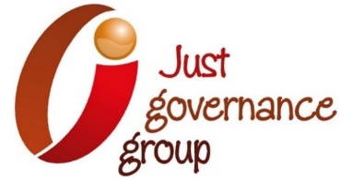

**Roundtable Schedule**

**Lessons from using Most Significant Change to evaluate Governance and Human Rights Initiatives in International Development**

*Just Governance Group (JGG)*

**June 4, 2020**

| **Time** | **Activity** | **Lead** |
| --- | --- | --- |
| 10:00-10:05 hrs | Welcome and self-introduction | Kimberly Inksater, JGG executive director |
| 10:05-10:15 hrs | Presentation of first case study: Lessons from SASA!, a methodoly to prevent violence against women, the case of Haiti | Sara Siebert, VAWG Prevention Specialist/Technical Advisor at Raising Voices and Beyond Borders |
| 10:15-10:45 hrs | First round of collective reflections | Sara Siebert, VAWG Prevention Specialist |
| 10:45-10:55 hrs | Presentation second case study: Lessons from the Corruption, Justice and Legitimacy Program, the case of the Democratic Republic of Congo | Cheyanne Church- Professor of  Aid Effectiveness and Human Security at Tufts University and Founder of Besa. |
| 10:55-11:25 hrs | Second round of collective reflections | Cheyanne Church- Professor of  Aid Effectiveness and Human Security at Tufts University and Founder of Besa. |
| 11:25-11:30 hrs | Conclusion and closing remarks | Kimberly Inksater, JGG executive director |